North Carolina

Racial Equity

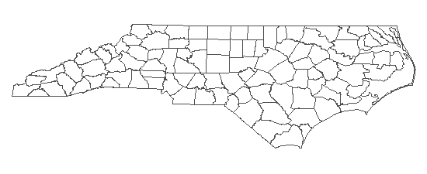
Report Card

2019 • Produced by Youth Justice Project

What are the Racial Equity Report Cards (RERCs)? The RERCs use public data to provide a snapshot of a community’s school-to-prison pipeline, including any racial disproportionalities that exist.
What is the school-to-prison pipeline (STPP)? The STPP is the system of policies and practices that push students out of school and into the juvenile and adult criminal systems. The STPP has many entry points. Once students are caught in the pipeline, it can be very difficult for them to reengage and be successful in school. In almost every NC community, students of color are overrepresented at each entry point to the pipeline.
What is the purpose of the RERCs? The RERCs are a starting point for community education, discussion, and advocacy. There are many causes of racial disproportionality including implicit racial bias of decision-makers, institutional and structural racism, and explicit discrimination against people of color. Together, these forces fuel racial disproportionality in a community’s STPP. The RERCs are not intended as an attack on the critically important public institutions that serve our youth, but rather, as a call-to-action for students, parents, advocates, policy makers, and institutional stakeholders to collectively examine the causes of racial inequity in their community and develop solutions that will help young people, especially youth of color, avoid and escape the school-to-prison pipeline.
Want to learn more? To see RERCs for other school districts or the state, learn more about the RERCs, and access additional resources, visit us at www.youthjusticenc.org/racial-equity-report-cards.

Student Demographics
2017-18

Academic Achievement

Total Student Population:
1,536,872

• • • • • • • • • IN THE STATE • • • • • • • • •

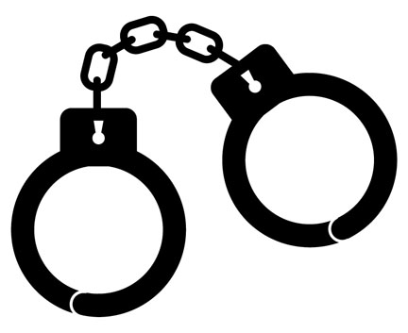
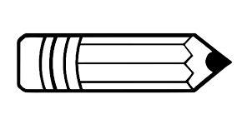

3.7X

2X

4.3X

White students in grades 3-8 were 2 times more likely to score “Career and College Ready” on end-of-grade exams than Black students. (2017-18)

Black youth were 3.7 times more likely than White youth to be referred to juvenile delinquency court. (2017)

Black students were 4.3 times more likely than White students to receive a short-term suspension. (2016-17)

School Year 2017-18

School Personnel

Students by Race

Teachers by Race

A diverse school staff representative of the student body is one important way to help equalize opportunities for students of color. A recent study revealed that low-income Black students in North Carolina who had at least one Black teacher in elementary school were significantly more likely to graduate high school and consider attending college. Despite this, North Carolina’s teaching force remains disproportionately White. In 2017-18, 79% of the state’s teachers were White, even though only 48% of the state’s student population was White.

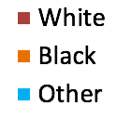

Principals by Race

Asst. Principals by Race

Academic Achievement

Students who are behind academically are more likely to have attendance issues, experience behavior struggles, and drop out of school. Statewide, only 30% of Black students in grades 3-8 scored “College and Career Ready” on their final exams, compared to 62% of White students in 2017-18. While standardized test scores are not a reliable measure of true ability for all students, they serve as the basis for many important decisions (e.g. course placement, grade promotion). Thus, low test scores negatively impact a student’s overall academic opportunities and outcomes.

% of Students in Grades 3-8 Scoring "College and Career Ready" on End-of-Grade Exams

School Year 2017-18

% of Students in Grades 9-12 Scoring "College and Career Ready" on End-of-Course Exams

% of Students Who Graduate High School Within 4 Years of Entering

School Discipline
`

Any time a student spends out of the classroom for disciplinary reasons is time that student is not learning. Research shows that out-of-school suspension is ineffective at correcting student misbehavior and, instead, increases a student’s chances of experiencing negative academic outcomes and future court involvement. Further, the use of suspension has no measurable positive impact on overall school safety.
Importantly, some students are more likely to receive a suspension. Statewide, Black students received 57% of all short-term suspensions, even though they made up only 25% of the student population in 2016-17. This disproportionality exists despite the fact that studies show Black and White students misbehave at similar rates.
While many schools have decreased suspensions in recent years, there has been an increase in other discipline measures that take students out of their normal classroom or school, such as in-school suspension or transfers to alternative schools. Like suspension, these measures disrupt student learning and are often ineffective unless appropriate support is provided in the alternative setting.

2016-17 State Overview
In-School Suspensions  (half-day or more) | 235,442
Short-Term Suspensions (STS)  (1-10 school days) | 208,539
High School STS Rate  (Per 100 Students) | 18.2
Disciplinary Reassignments to Alternative Programs | 5,054
Alternative Learning Program Placements | 13,397
Long-Term Suspensions  (more than 10 days) | 695
Expulsions (indefinite) | 18

% of Students by Race
2017-18

% of Short-Term Suspensions by Race

School Year 2016-17

Short-Term Suspension Rates by Race

School Year 2016-17

---- Missing Information ----
Unfortunately, statewide data is not publicly available for many important measures such as:
- Use of in-school suspension at the school and district level
- Suspensions disaggregated by offense, grade, length, etc.
- Assignments to alternative programs
- School-based arrests & use of force
These are only a few examples of data that should be collected and reported by the N.C. Department of Public Instruction.

Number of Short-Term Suspensions Per 100 Students

2017 State Overview
Total # of Juvenile Court Complaints | 28,165
Total # of Juvenile Detention Admissions | 2,742
Total # of Youth Development Center Commitments | 187
Criminalization of youthful misbehavior has immediate and long-term consequences. Studies show youth who are court involved are more likely to reoffend and experience lifelong entanglement in the criminal system. Furthermore, court involvement can impact a youth’s access to education, employment, housing, public benefits, voting rights, and other sources of opportunity and support. Statewide, 42% of juvenile court referrals came from schools in 2017-18. Further, 54% of all juvenile complaints were filed against Black youth even though they make up only a quarter of the population.
The data in this section only includes youth under 16 years old. In North Carolina, all 16- and 17-year-olds are automatically sent to the adult criminal system regardless of the offense. This will change in December 2019 when most youth under age 18 will instead be sent to the juvenile system, with only the most serious offenses sent to adult criminal court. However, until this change takes effect, data on arrests and detention for youth who are 16 and older is not publicly available.

Youth Justice Project of the Southern Coalition for Social Justice works to ensure equity, fairness, and justice for youth in high-quality education, juvenile, and criminal systems.
For more information, visit us at youthjusticenc.org.

Calendar Year 2017

% of Youth Development Center Commitments by Race

% of Juvenile Complaints that were School Based
July 2017-June 2018

Calendar Year 2017

Calendar Year 2017

% of Juvenile Detention Admissions by Race

% of Juvenile Complaints by Race

Court Involvement
`

